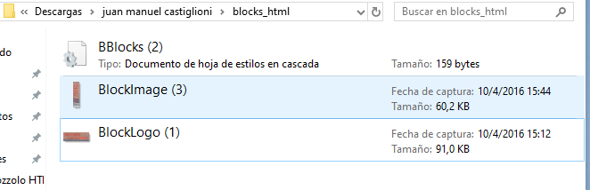

EVIDENCE 5

The image does not maintain the aspect ratio